LAB EXPERIMENT RECORD

SET 2 – Customer Feedback Analysis

Department | B. Tech AI&DS
Course Code / Course Name | DSA0602 / Data Handling and Visualization
Experiment | Data Visualization using R
Name | Peram Mahitha
Register Number | 192524136
Date | 29 September 2026
Day | Tuesday

AIM:

To analyze customer satisfaction and feedback data using R programming and visualize the results using histogram, pie chart, stacked bar chart, and word cloud.

Program 1 – Customer Age Distribution

CODE:

# Customer Feedback Analysis - Set 2

# Create dataset
customer_id <- c(1, 2, 3, 4, 5)
age <- c(25, 30, 35, 28, 40)
satisfaction <- c(4, 5, 3, 4, 5)

data <- data.frame(customer_id, age, satisfaction)

# Histogram of customer ages hist(data$age,
main = "Distribution of Customer Ages", xlab = "Age",
ylab = "Number of Customers", col = "skyblue",
border = "black")

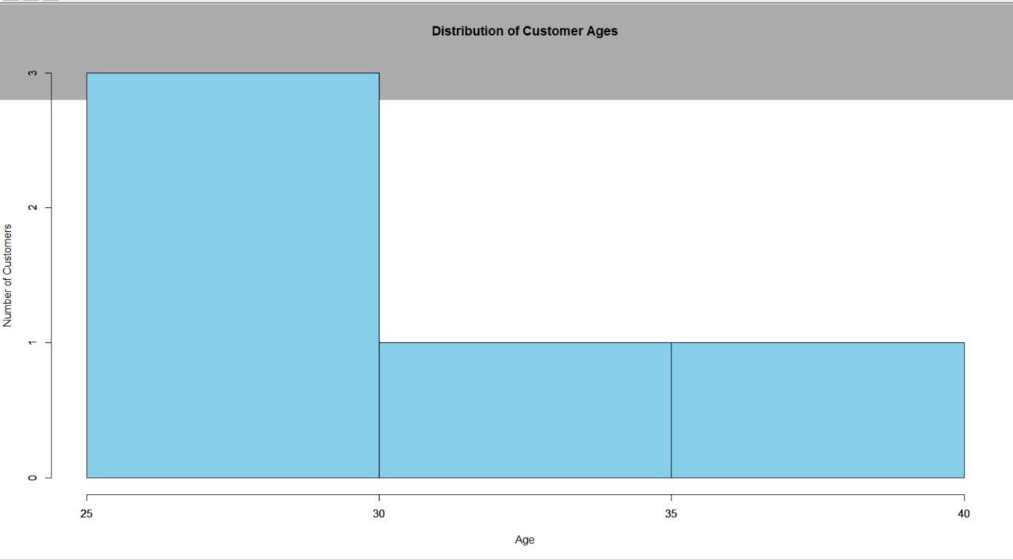
OUTPUT:

Observation: The histogram represents the distribution of customers based on age. The ages range from 25 to 40 years.

Program 2 – Customer Satisfaction Distribution

CODE:

# Customer Feedback Analysis - Set 2

# Create dataset
customer_id <- c(1, 2, 3, 4, 5)
age <- c(25, 30, 35, 28, 40)
satisfaction <- c(4, 5, 3, 4, 5)

data <- data.frame(customer_id, age, satisfaction)

# Calculate satisfaction frequency satisfaction_count <- table(data$satisfaction)

# Create labels
labels <- paste("Score", names(satisfaction_count))

# Pie chart pie(satisfaction_count,
labels = labels,
main = "Overall Distribution of Customer Satisfaction Scores", col = rainbow(length(satisfaction_count)))

OUTPUT:

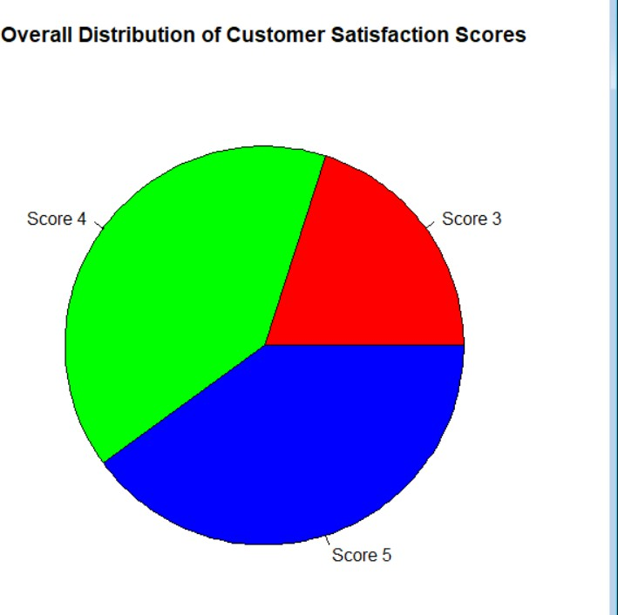
Observation: Satisfaction scores 4 and 5 occur most frequently, while score 3 occurs only once

Program 3 – Satisfaction by Age Group

CODE:

# Customer Feedback Analysis - Set 2 # Create dataset
customer_id <- c(1, 2, 3, 4, 5)
age <- c(25, 30, 35, 28, 40)
satisfaction <- c(4, 5, 3, 4, 5)

data <- data.frame(customer_id, age, satisfaction)

# Create age groups data$age_group <- cut(data$age,
breaks = c(20, 29, 39, 49),
labels = c("20-29", "30-39", "40-49"))

# Create frequency table
age_satisfaction <- table(data$age_group, data$satisfaction)

# Stacked bar chart barplot(age_satisfaction,
beside = FALSE,
main = "Customer Satisfaction by Age Group", xlab = "Age Group",
ylab = "Number of Customers",
col = rainbow(ncol(age_satisfaction)), legend = colnames(age_satisfaction))

OUTPUT:

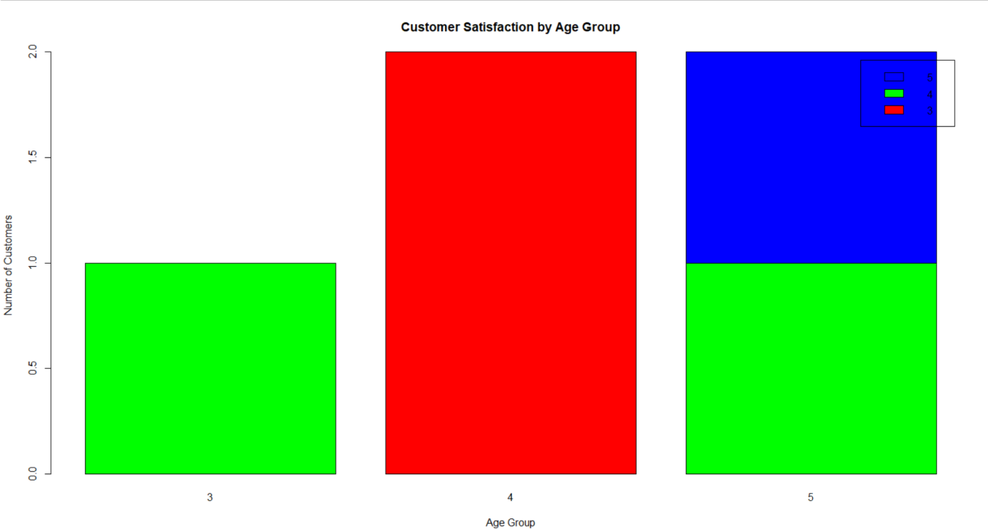

Observation: The stacked bar chart shows how satisfaction scores are distributed among different age groups. The 20–29 age group contains satisfaction scores of 4, while the 30–39 and 40–49 groups contain different satisfaction levels.

Program 4 – Customer Feedback Sentiment

CODE:

# Load libraries library(tm) library(wordcloud)

# Sample open-ended customer feedback feedback <- c(
"The service was excellent and very friendly", "I am very satisfied with the service", "Excellent customer support and fast service", "The product quality was good",
"Very happy with the customer service",

"The service was fast and excellent", "Good product and friendly staff"
)

# Create corpus
corpus <- Corpus(VectorSource(feedback))

# Convert to lowercase
corpus <- tm_map(corpus, content_transformer(tolower))

# Remove punctuation
corpus <- tm_map(corpus, removePunctuation)

# Remove numbers
corpus <- tm_map(corpus, removeNumbers)

# Remove common stop words
corpus <- tm_map(corpus, removeWords, stopwords("english"))

# Create word frequency
word_matrix <- TermDocumentMatrix(corpus) word_freq <- sort(rowSums(as.matrix(word_matrix)),
decreasing = TRUE) # Create word cloud wordcloud(names(word_freq),
freq = word_freq, min.freq = 1, random.order = FALSE, colors = rainbow(10), scale = c(3, 0.5),
main = "Customer Feedback Word Cloud")

OUTPUT:



Observation: The word cloud identifies frequently occurring words in customer feedback. Words such as excellent, service, good, friendly, satisfied, and customer represent common positive sentiments.

Procedure

- Create the customer dataset containing Customer ID, Age, and Satisfaction Score.
- Store the data in an R data frame for easy analysis and visualization.
- Analyze customer age distribution by creating a histogram with appropriate title and axis labels.
- Calculate the frequency of each satisfaction score and represent the overall satisfaction distribution using a pie chart with labels.
- Create age groups such as 20–29, 30–39, and 40–49 using the cut() function.
- Create a frequency table of satisfaction scores for each age group.
- Visualize satisfaction by age group using a stacked bar chart with a legend.

- Prepare open-ended customer feedback as text data for sentiment analysis.
- Create a text corpus using the tm package and preprocess the feedback by converting text to lowercase and removing punctuation, numbers, and stop words.
- Calculate word frequencies and generate a word cloud using the wordcloud package.
- Interpret all visualizations to identify customer age patterns, satisfaction levels, satisfaction across age groups, and common words/sentiments.
- Summarize the findings to understand the overall customer satisfaction and feedback trends.

Result

The analysis shows that the customers generally have positive satisfaction levels, with scores 4 and 5 appearing most frequently. The age distribution ranges from 25 to 40 years, and the word-cloud analysis indicates predominantly positive feedback about service, quality, and customer support.

Key R Functions Used

R Function | Purpose
c() | Creates vectors of customer data
data.frame() | Creates the customer dataset
table() | Calculates frequency of satisfaction scores
hist() | Creates the histogram
pie() | Creates the pie chart
cut() | Divides customer ages into age groups
barplot() | Creates the stacked bar chart
install.packages() | Installs required R packages
library() | Loads required packages
Corpus() | Creates a text corpus for feedback
VectorSource() | Converts feedback text into a text source
tm_map() | Performs text preprocessing
tolower() | Converts text to lowercase

removePunctuation() | Removes punctuation
removeNumbers() | Removes numbers
removeWords() | Removes stop words
stopwords() | Provides common English stop words
TermDocumentMatrix() | Creates a matrix of words and documents
rowSums() | Calculates word frequencies
sort() | Sorts word frequencies
wordcloud() | Generates the word cloud

